

ST. JOHN THE APOSTLE PARISH

5457 Trafalgar Street, Vancouver, B.C. V6N 1C1

T 604-266-8800 parish.sjoh.rcav.org www.sjaparish.ca

ST. JOHN THE APOSTLE PARISH BULLETIN

5457 Trafalgar Street, Vancouver, BC V6N 1C1 T 604.266.8800 parish.sjoh@rcav.org www.sjaparish.ca

Bulletin: November 01, 2020



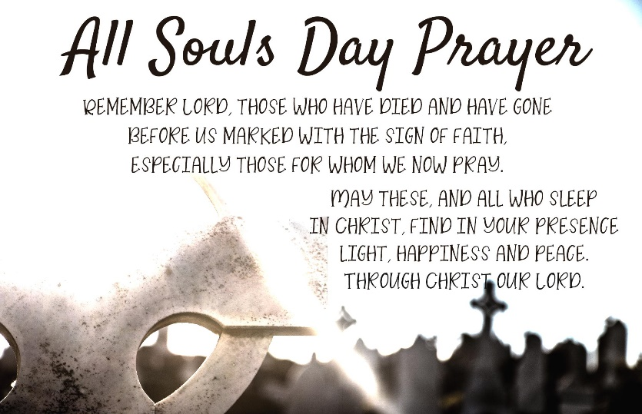

All Souls Envelopes are available at the back of the church where you can write names of your deceased loved ones and friends. Please drop the envelopes at the Sunday collection or the rectory office. Your deceased loved ones and friends will be remembered during holy Mass throughout the whole month of November.

**A glorified hide-and-seek**

The Fifth Joyful Mystery of the Rosary is the Finding of Jesus in the Temple (Luke 2:41-52). The Catechism of the Catholic Church states: “The finding of Jesus in the temple is the only event that breaks the silence of the Gospels about the hidden years of Jesus. Here Jesus lets us catch a glimpse of the mystery of his total consecration to a mission that flows from his divine sonship: ‘Did you not know that I must be about my Father’s work?’ Mary and Joseph did not understand these words, but they accepted them in faith. Mary ‘kept all these things in her heart’ during the years Jesus remained hidden in the silence of an ordinary life.”

The losing and the finding of Jesus anticipated the death and resurrection of Christ. Venerable Fulton J. Sheen wrote, “All through His infancy there was talk of ‘contradiction,’ ‘swords,’ ‘no room,’ ‘exile,’ ‘slaughter,’ and now there was ‘loss.’ In those three days, Mary came to know one of the effects of sin, namely, the loss of God. Though she was without sin, nevertheless she knew the fears and the loneliness, the darkness and the isolation which every sinner experience when he loses God. It was a kind of glorified hide-and-seek. He was hers; that was why she sought Him. He was on the business of redemption; that was why He left her and went to the temple. She had her dark night of the body in Egypt; she would now have her dark night of the soul in Jerusalem. Mothers must be trained to bear crosses. Not only her body, but also her soul would have to pay dearly for the privilege of being His mother. She would later suffer another three-day loss from Good Friday to Easter Sunday. This first loss was part of her preparation.”

There are parallels between the find of Jesus in the temple (Luke 2:41-52) and the empty tomb story (Luke 24:1-8).

Luke 2:46 states: “After three days they found him in the temple”, and in Luke 24:7, the two men told the women that the Son of Man must “on the third day rise”.

Jesus asked Our Lady, “How is it that you sought me?” (Luke 2:49) and the two men asked the women, “Why do you seek the living among the dead?” (Luke 24:5)

Our Lady “kept all these things in her heart.” (Luke 2:51) The term translated as “things” could also mean “words”. The holy women “remembered his words”. (Luke 24:8)

Dr. Pius Parsch wrote, “Mary represents the Church; the Church through suffering and participation in Christ’s work comes into possession of the graces of redemption and awaits the great, final manifestation of Christ. This Second Coming was prefigured by the finding of the boy Jesus in the temple. Our Mother the Church is now seeking Him ‘in sorrow.’ Then when He will have been truly found, that is, when He comes at the Parousia, He will say, ‘Did you not know that I must be about My Father’s business?’, that I must be enthroned at My Father’s right hand? The holy sacrifice of the Mass is an anticipated actualization of His return”.

The Gospel summed up the hidden life of Jesus with these words: “And he went down with them and came to Nazareth, and was obedient to them” (Luke 2:51)

The Catechism states: “The obedience of Christ in the daily routine of his hidden life was already inaugurating his work of restoring what the disobedience of Adam had destroyed.”

St Josemaría Escrivá wrote, “His hidden years are not without significance, nor were they simply a preparation for the years which were to come after—those of his public life. […] God wants our Lord’s whole life to be an example for Christians. […] Our Lord wants many people to ratify their vocation during years of quiet, unspectacular living”.